How to Get Started with Print Shop Pro

First you must register as a new user of the application. The following instructions will walk you through how to get started.

1. Open a browser and type in **http://Okcprintshop** or click this [link](http://okcprintshop/PSP/app/PSP_Start.asp).
2. Click the **‘Log In’** Hyperlink in the upper right hand corner:

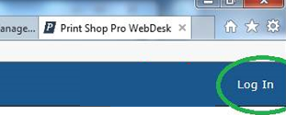

1. In the **‘User Name’** field type your COKC email address like [first.last@okc.gov](mailto:first.last@okc.gov) (Active Directory ‘userPrincipalName’)
2. In the **‘Password’** field type your Network Password
3. Click **‘Login’**

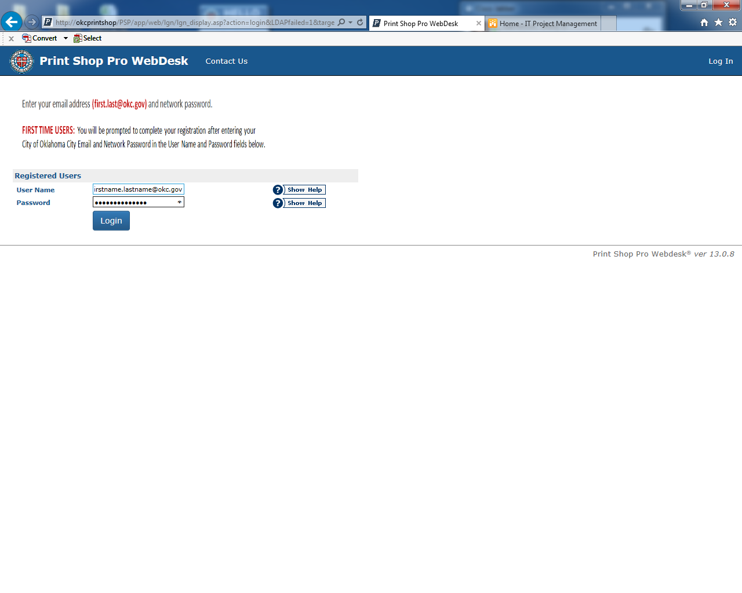

1. A new screen will appear, prepopulated with your City of Oklahoma City Account information. The only thing you need to update on this page is the **‘Site’** field dropdown.

**Note:** Choose the Department you are **employed by**, even if you have multiple Department/Divisions you order print work for.

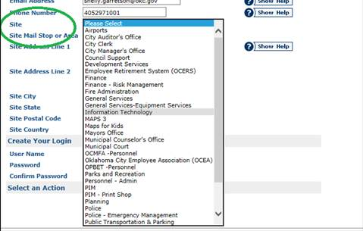

1. Any remaining fields will populate based on the **‘Site’** you have chosen.
2. Click on **‘Update’.**

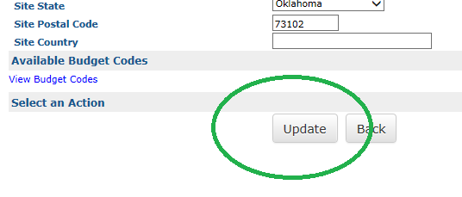

1. You should be taken to the next page, which says ‘**Registration Confirmation**’ in the heading and two hyperlink options:
   1. Go-Click here to view your profile
   2. Go-Return to homepage
2. Click on the **‘Return to homepage’** option or you may proceed with a ‘**New Order**’**\*\*** at this time:

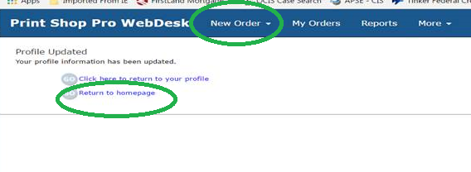

**\*\***Please refer to ‘**How to Place an Order in Print Shop Pro**’ for further ordering instructions.

1. When you have completed your Print Shop Pro activities, you may Choose **‘Log Out’** or close your browser completely.

